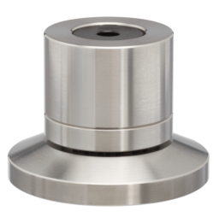
CERABASE° classic

Load capacity: 500kg (set of 4)

- stainless steel, hand-polished, height-adjustable screw-on technology,
incl. assembly accessories

order no. | article | MOC
cbs-4 | Cerabase 4 classic [set of 4] | 680 €
cbs-3 | Cerabase 3 classic [set of 3] | 510 €
cbs-1 | Cerabase 1 classic [single unit] | 195 €

CERABASE° compact

Load capacity: 300kg (set of 4)

- stainless steel, hand-polished, height-adjustable screw-on technology,
incl. assembly accessories

order no. | article | MOC
cbs-4 cmp | Cerabase 4 compact [set of 4] | 580 €
cbs-3 cmp | Cerabase 3 compact [set of 3] | 435 €
cbs-1 cmp | Cerabase 1 compact [single unit] | 165 €

CERABASE° slimline

Load capacity: 300kg (set of 4)

- stainless steel, hand-polished, screw-on technology (slimline not height-adjustable), incl. assembly accessories

order no. | article | MOC
cbs-4 slm | Cerabase 4 slimline [set of 4] | 460 €
cbs-3 slm | Cerabase 3 slimline [set of 3] | 345 €
cbs-1 slm | Cerabase 1 slimline [single unit] | 135 €

CERABASE° B&W
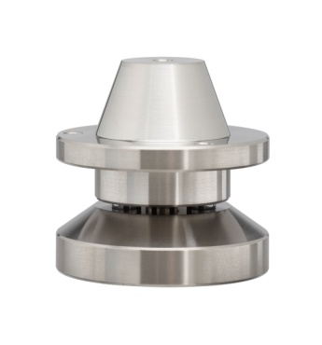
(special version for B&W series 800 / series 800 Diamond speakers)

Load capacity: 500kg (set of 4)

- stainless steel, hand-polished, height-adjustable screw-on technology,
incl. assembly accessories

order no. | article | MOC
cbs-4 B&W | Cerabase 4 B&W [set of 4] | 680 €
cbs-8 B&W | Cerabase 8 B&W [set of 8] | 1360 €

CERAPUC°

Load capacity: 300kg (set of 4) / 225kg (set of 3)

- stainless steel, hand-polished, height-adjustable screw-on technology,
incl. assembly accessories

order no. | article | MOC
cpc-4 | Cerapuc 4 [set of 4] | 400, €
cpc-3 | Cerapuc 3 [set of 3] | 300, €
cpc-1 | Cerapuc 1 [single unit] | 115, €

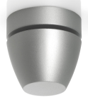
CERABALL° universal

Load capacity: 160 kg (set of 4) / 120 kg (set of 3)

- aluminum silver or black anodized - height-adjustable screw-on technology

order no. | article | MOC
cb-uni-4 (-s/-b) | Ceraball° universal [set of 4] silver or black | 200, €
cb-uni-3 (-s/-b) | Ceraball° universal [set of 3] silver or black | 150, €
cb-uni-1 (-s/-b) | Ceraball° universal (single unit) silver or black | 60, €

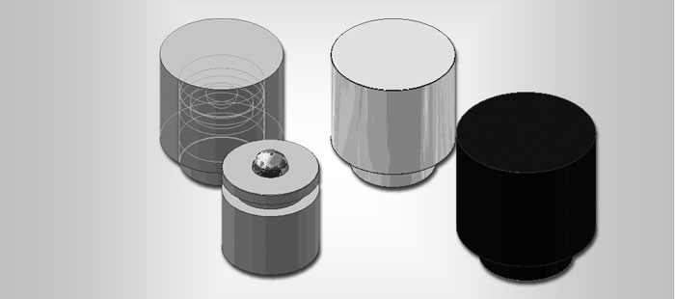
CERAONE

Optimum range of application: Up to 120 kg (set of 4)
Dimensions: Výška : 26mm; Ø vonkajší : 25mm; Ø vnútorný valec: 17mm

Load capacity: 120 kg pre 1 set / 4 ks

- aluminum silver or black anodized - height-adjustable screw-on technology

order no. | article | MOC
 | Ceraone set 4 kusy silver or black | 100, €
 | Ceraone 1 kus silver or black | 25, €

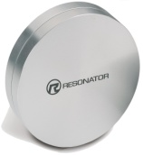
Resonator° – resonance dissipater
Absorbér parazitných rezonancií . Eliminácia mikrofonického efektu v kritickom pásme počutia. Výrazné zníženie odstupu hluku od užitočného signálu, spôsobí výrazne čistejší a presnejší prejav reprodukovaného zvuku v celom počuteľnom pásme .

- application area: 200 Hz – 1000 Hz
- lacquered aluminium

order no. | article | MOC AKCIA - 42%
res-s | Resonator - silver | 333 € 195 €
res-b | Resonator - black | 333 € 195 €
 | Resonator - red | 333 € 195 €

